**Ambient Light Sensor - 1**

Model TEMT6000

Manufacturer Vishay

Features:

* Adapted to human eye responsivity
* Wide angle of half sensitivity ϕ = ± 60°

**Characteristics:**

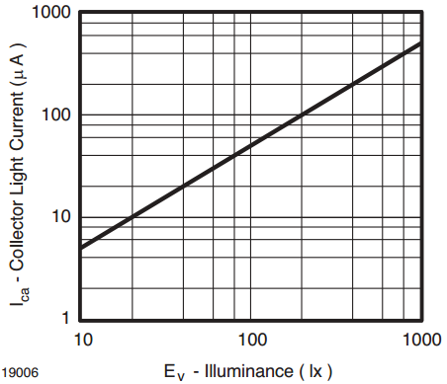 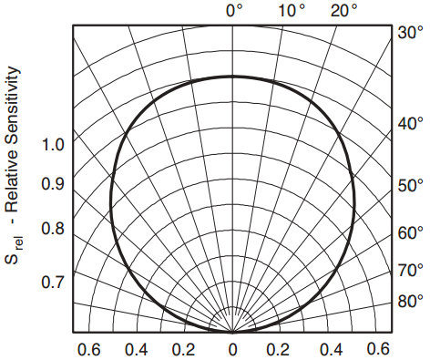

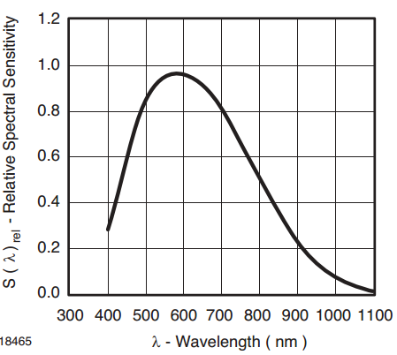 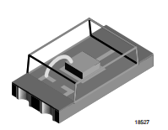

**Ambient Light Sensor – 2**

Model TSL2561

Manufacturer Texas Advanced Optoelectronic Solutions

Features

* Two channels, IR, IR+ Visible, mimic human eye response
* 0.1 – 40k lux

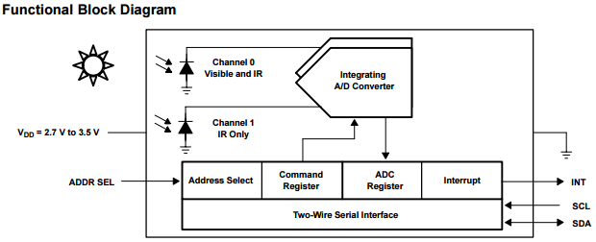

**Characteristics**

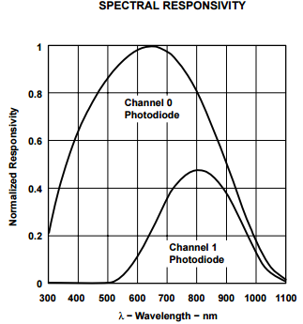 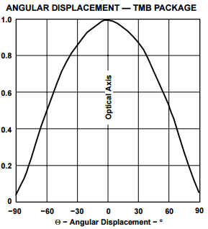

**Ambient Light Sensor – 3**

Model TSL2591

Manufacturer AMS

Features

• Two channels, IR, IR+ Visible, mimic human eye response

• 188 uLux sensitivity, up to 88,000 Lux

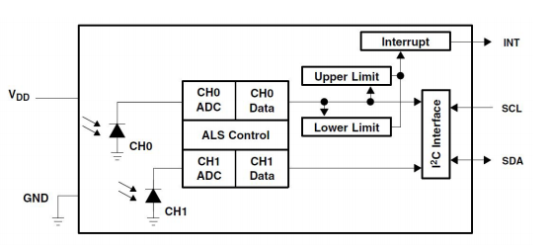

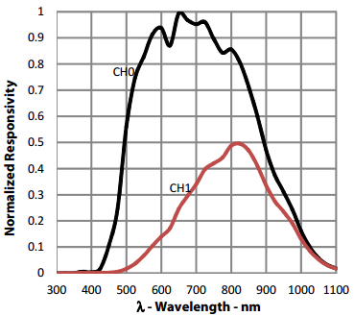 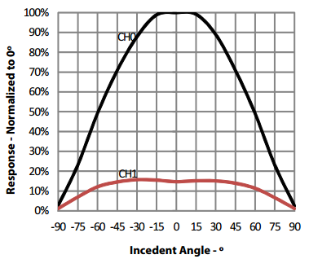

**RGB Light Sensor**

Model ISL29125

Manufacturer Intersil

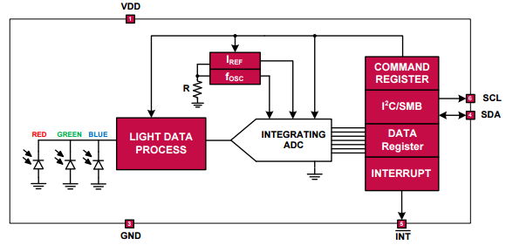 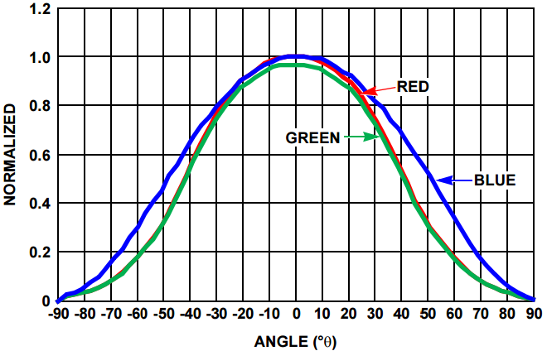

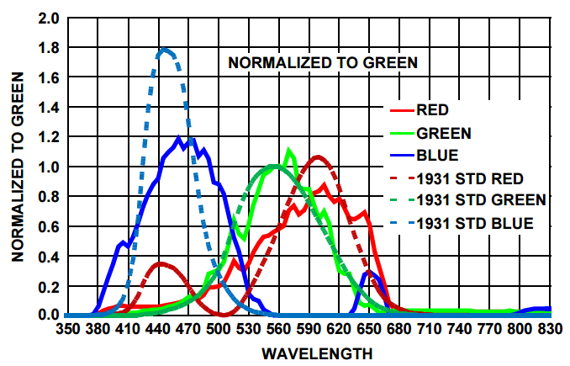

**UV Sensor**

Model GUVA-S12SD

Manufacturer Roithner LaserTechnik GmbH

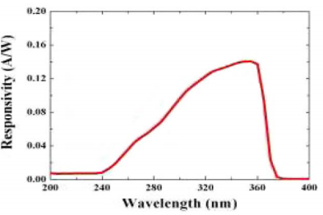

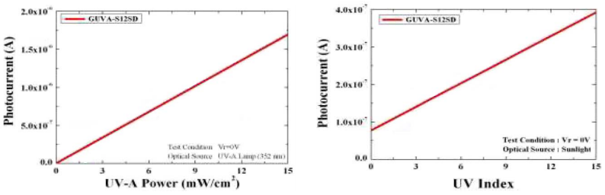

**UV-IR-Visible 3-in-1**

Model SI1145

Manufacturer Silicon Labs

Features

* Integrated UV index sensor
* 1-128k lux, 0.1 lux resolution
* I2C Serial communications

